Assignment for the Course "Current Research Areas II " 2026
You were already introduced to yard robots and especially robotic lawnmowers and some of its functions. Now, a Matlab/Simulink model of the abstracted robot model (mobile robot with differential drive) should be created, and the so-called "Random-Walk" should be implemented.
The implementation should be done in groups, and the task will be graded based on a final presentation where you explain the algorithm you developed and present the implementation and simulation results.

Description:
- Mobile robot with differential drive, as introduced beforehand
- Mowing area as described
- Coil arrangement according to the sketch
  - 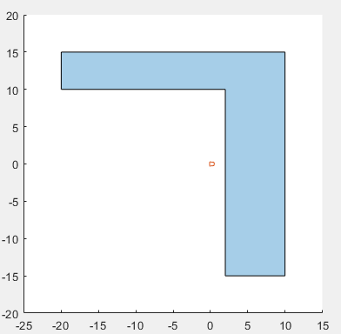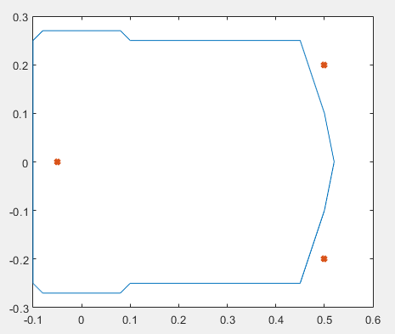
- Input variables are:
  - Translational speed with $v_{max}=± 0.5\frac{m}{s}$
  - Rotation speed with $ω_{max}=± 1\frac{rad}{s}$
- The control unit on the mower operates at a sampling rate of $T_{s}=10ms$
- Simulation time = 6000s

Task 01: link to files: https://github.com/samuelzoettl/mci_cra2/tree/main/03_Tasks/Task_01
- Implement the mathematical model as a nonlinear state-space model.
- Simulate the model in Simulink.
- Implement a typical garden geometry (hexagon with right angles = L-shape).
- Implement the coil signals of the robotic mower.
- The output signal should indicate "Inside" within the garden and "Outside" outside the field.
- Implement a state-flow chart with at least the following functions:
  - "Forward"
  - "Backward"
  - "Right Turn"
  - "Left Turn"
  - "Stop"
- Ensure that the mower can only operate within the garden aka Working Area (at least one coil "Inside").
  - No sensor coil should stay outside of the working area for more than 3 (?) seconds
  - One Coil has always to be inside
  - Use the state-flow chart and coil signals for the implementation
- Develop an algorithm to ensure the entire garden is mowed.
  - Only use the coil signals as input signals.
  - How do you implement “mowing” (what area is mowed, when the mower travels through the Working Area)
  - Think of ways to measure the progress and efficiency of your mowing logic
  - When do you abort your mowing session?
  - Formulate software requirements. also note, how you want to test against them
  - Implement tests to ensure your most critical requirements are fulfilled
- Extend the Simulink model with your algorithm.
- Simulate the extended model
- Present proof for the efficiency (eg create a plot; show data) of the algorithm.
  - You could plot the % of mowed area against time and compare algorithms
- Start with the model “task.slx” and take a look at “demo_original.slx” for inspiration if needed

Task 02:
- Analyzing the results of the Task 01, we can conclude that the mower does not mow the areas close to the borders of the area. This results in unattractive edges, a problem also very common in real live lawn mower robots.
The reason is quite simple: The cutting device is located more towards the center of the robot, whereas the sensor coils for the perimeter wire detection are located in the front of the machine.
  - Add a separate maneuver to a chosen mower logic (from the included models). Let the robot follow the perimeter wire and mow the edge (use the sensor coils to drive along the wire) before you start with the established mowing logic. You will need a condition to end this edge mowing operation, that works independently from the shape of the garden.
    - Compare the base models area coverage to your extended model

Task 03: link to files: https://github.com/samuelzoettl/mci_cra2/tree/main/03_Tasks/Task_03
- Lets automate using live scripts and ai
Task 01 and Task 02 were Simulink centric but now we try to work on automations using matlab live scripts. Utilize the matlab copilot ai for quicker results
you can use the LIVE Script “Start_here__LiveScript_for_analysis_and_plots.mlx” for inspiration.
- Generate live scripts, that can do the following:
  - Load a model from the model folder via dropdown menu
  - Generate figures with a proper legend
  - Add interactive elements
  - Let the ai draw an alternative mower silhouette and make it work
  - Run different models by itself and compare the results of the models with data and figures
  - Choose the best model
  - Implement Get and Set parameters for a selected model tune a given parameter and plot efficiency over this parameter. Eg. Velocity, rotational speed, turning angle
  - Let the ai design a set of areas
  - Implement drop down for area select
  - Let the script test a model on different areas (L, circular shaped, …) and show the efficiency on the areas and more data
- Reflect on your development process. How does the usage of ai influence your productivity

Task 04:
- Work on Script and Model with the help of ai to:
  - Implement a new parameter in a selected model: number of mowers;
  - Let multiple mowers mow in one run
  - Let the efficiency be plotted over number of mowers
- Work on Script and Model with the help of ai to:
  - Find the most efficient mowing strategy for a selected area
- Reflect on your development process. How does the usage of ai influence your productivity

Description of Demo files:
- initDemo and stopDemo are called from within the Simulink model (don’t call the StopFn from the Simulink model callback when working with live scripts)
- you can use the LIVE Script “Start_here__LiveScript_for_analysis_and_plots.mlx” to analyze the coverage and plot some data
- the models should be placed in the folder models

